Day 24 - 18th Aug 2026

Demo 1

java
@Entity
public class Author {
@Id
@GeneratedValue(strategy = GenerationType.IDENTITY)
private Long id;
private String name;

// Books are loaded only when accessed
@OneToMany(mappedBy = "author", fetch = FetchType.LAZY)
private List<Book> books;
}

java
Author author = entityManager.find(Author.class, 1L);
// No SQL for books yet
System.out.println(author.getBooks().size());
// Triggers SQL: SELECT * FROM book WHERE author_id = 1;

And

Demo2

java
@Entity
public class Author {
@Id
@GeneratedValue(strategy = GenerationType.IDENTITY)
private Long id;
private String name;

// Books are loaded immediately with Author
@OneToMany(mappedBy = "author", fetch = FetchType.EAGER)
private List<Book> books;
}

java
Author author = entityManager.find(Author.class, 1L);
// SQL joins Author + Books in one query

ORM Concepts and JPA
- How does Object-Relational Mapping (ORM) bridge the gap between object-oriented programming and relational databases, and what role does JPA play in this process?
ORM (Object-Relational Mapping) acts as a bridge between Java objects and relational database tables.

Java Database
------------------------------------------------
User object ↔ users table
user.id ↔ id column
user.name ↔ name column

JPA (Java Persistence API) is a Java specification that defines how Java objects should be persisted in a database.
It provides concepts such as:
- @Entity → maps a Java class to a table
- @Id → identifies the primary key
- @OneToMany → defines relationships
- @ManyToOne → defines relationships
- EntityManager → manages persistence operations
Hibernate is a popular implementation of JPA.

Hibernate Fundamentals
- Why is Hibernate considered a powerful JPA implementation, and how does its caching mechanism improve application performance?
Hibernate is a popular implementation of JPA because it provides many features that make database operations easier and more efficient.
Key points:
- Automatic SQL generation – Hibernate generates SQL for common CRUD operations.
- Object-Relational Mapping – Maps Java objects to database tables.
- Relationship management – Supports @OneToOne, @OneToMany, @ManyToMany, etc.
- Lazy loading – Loads related data only when needed.
- Transaction management – Works well with Spring transactions.
- Caching – Can store frequently accessed data in memory.
- Database independence – Helps applications work with different relational databases.

🔹 Entity Mapping and Relationships (1:1, 1:N, N:M)
- Conceptually, how do different entity relationships (One-to-One, One-to-Many, Many-to-Many) affect database design and query complexity?

Entity relationships define how tables are connected in a relational database. The type of relationship affects the table structure, joins, and query complexity.
- One-to-One (1:1)
  - One record relates to one record.
  - Usually uses a foreign key.
  - Simple database structure.
  - Queries are generally simple.
- One-to-Many (1:N)
  - One record relates to multiple records.
  - Foreign key is placed on the "many" side.
  - Requires joins when retrieving related data.
  - More records can increase query complexity.
- Many-to-Many (N:M)
  - Multiple records relate to multiple records.
  - Requires a junction/join table.
  - Usually requires multiple joins.
  - More complex queries and relationship management.
- Overall
  - Relationship type determines database structure.
  - More complex relationships generally require more joins.
  - Proper indexing and query design help maintain performance.

🔹 JPQL, Criteria API, and Native Queries
- What are the trade-offs between using JPQL, Criteria API, and Native SQL queries in terms of readability, flexibility, and performance?
• JPQL (Java Persistence Query Language)
- Works with entities and Java objects, not directly with tables.
- Easy to read and write.
- Good for most common queries.
- Database-independent.
- Less flexible for very database-specific operations.
• Criteria API
- Builds queries programmatically using Java code.
- Useful for dynamic queries where conditions change at runtime.
- Type-safe and avoids manually writing query strings.
- Can become verbose and harder to read.
- Usually more complex to maintain.
• Native SQL
- Uses the database's actual SQL syntax.
- Provides the most flexibility and database-specific features.
- Useful for complex queries and database-specific optimizations.
- Less portable between different databases.
- Can be harder to maintain.
- Performance can be better when carefully optimized, but there is no automatic guarantee that native SQL is faster.

🔹 Spring Data JPA Repositories
- How does Spring Data JPA simplify repository implementation, and what risks come with relying heavily on derived query methods?
• Spring Data JPA simplifies database access by providing ready-made repository interfaces.
• You don't need to write common CRUD implementations manually.
• You can extend interfaces such as JpaRepository.
• Provides methods like:
- save()
- findById()
- findAll()
- deleteById()
• Supports derived query methods based on method names.
Risks of relying heavily on derived queries
- Long method names can become difficult to read.
- Complex queries can make method names very complicated.
- Developers may have difficulty understanding the actual SQL being generated.
- Changes to entity properties can break derived query methods.
- Less control over database-specific optimizations.
- For complex queries, JPQL, Criteria API, or native SQL may be more appropriate.

- LazyInitializationException if accessed outside transaction when will this exception occur? During lazy or eager?

Task 1:
Step 1:
Open docker – running mode on
Step 2:
Keep redis ready
Step 3:
Pick any of your banking app demo .. to integrate redis in it
Step 4:
Add dependencies in pom.xml
<!-- Spring Boot Redis Starter -->
<dependency>
<groupId>org.springframework.boot</groupId>
<artifactId>spring-boot-starter-data-redis</artifactId>
</dependency>

<!-- Optional: Lettuce client (default) -->
<dependency>
<groupId>io.lettuce.core</groupId>
<artifactId>lettuce-core</artifactId>
</dependency>

Step 5:
Configure redis in your application.properties file

# Redis connection details
spring.redis.host=localhost
spring.redis.port=6379

# Enable Redis as cache provider
spring.cache.type=redis

Step 6:
In your main bankingapp.java file enable cacheing
@enableCaching

Like for example
@SpringBootApplication
@EnableCaching // 🔑 Enables Spring Cache abstraction
public class BankingApplication {
public static void main(String[] args) {
SpringApplication.run(BankingApplication.class, args);
}
}

Step 7:
Ensure you have accounts.java
Step 8:
repository .java file
Step 9:
Use @cachable in service layer java file for write - through, chache -aside, chache evict.
Like

@Service
public class AccountService {

@Autowired
private AccountRepository accountRepository;

// Cache-Aside: First call hits DB, result stored in Redis
@Cacheable(value = "accounts", key = "#accountId")
public Account getAccountDetails(Long accountId) {
System.out.println("Fetching from DB...");
return accountRepository.findById(accountId).orElseThrow();
}

// Write-Through: Updates DB and Redis simultaneously
@CachePut(value = "accounts", key = "#account.id")
public Account updateAccount(Account account) {
return accountRepository.save(account);
}

// Explicit Invalidation: Removes entry from Redis when deleted
@CacheEvict(value = "accounts", key = "#accountId")
public void deleteAccount(Long accountId) {
accountRepository.deleteById(accountId);
}
}

Step 10:
Ensure you have
Controller.java

Step 11:
Very by using these commands
redis-cli
keys *
get accounts::101
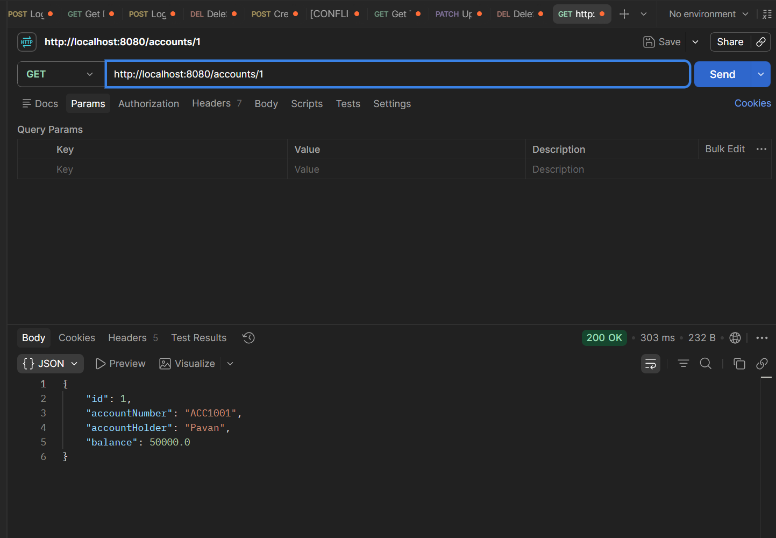
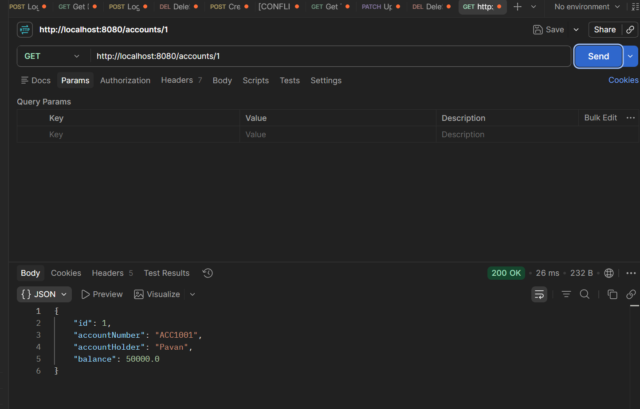

---------------------------------------------------------------------------------
Distributed Caching Considerations
- Q: How does replication lag in a distributed Redis cluster affect consistency, and what strategies can mitigate its impact on read-heavy applications?
Replication lag occurs when a Redis replica has not yet received the latest data from its primary.
For example:
Client → Primary → Replica
If the client writes balance = 500 to the primary and immediately reads from a replica, the replica might still return the old value, such as balance = 100.
This causes eventual consistency and potentially stale reads.
Impact on read-heavy applications
- Reads from replicas may return outdated data.
- Users may see different values depending on which replica handles their request.
- Recently updated data may temporarily appear unchanged.
- Critical operations such as account balances or stock prices can be problematic if stale data is accepted.
Strategies to mitigate it
- Read from the primary for data that requires the latest value.
- Read from replicas for non-critical data where slight staleness is acceptable.
- Read-after-write consistency — after a write, route subsequent reads for that user/key to the primary for a short period.
- Monitor replication lag and avoid replicas whose lag exceeds an acceptable threshold.
- Use TTL/cache invalidation to prevent stale data from remaining too long.
- Use Redis Sentinel/Cluster carefully to improve availability while understanding that replication is generally asynchronous.
- Separate critical and non-critical reads — critical reads use the primary; high-volume informational reads use replicas.

👥 Redis for Session Management
- Q: Why is Redis preferred over traditional databases for session management in high-traffic web applications, and what risks arise if persistence is not configured?
Redis is commonly preferred for session management in high-traffic applications because it is an in-memory key-value store, making session read/write operations extremely fast.
Why Redis is suitable
- Very fast — data is stored in memory, giving low-latency access.
- High throughput — can handle a large number of session requests.
- Easy expiration — TTL can automatically remove expired sessions.
- Centralized sessions — multiple application servers can access the same sessions.
- Scalable — Redis can be replicated and clustered.
- Reduces database load — avoids repeatedly querying the main database for session information.
What happens if persistence is not configured?
If Redis is running without persistence and Redis crashes or restarts:
- All in-memory sessions can be lost.
- Users may be logged out.
- Shopping carts or temporary user state stored in sessions may disappear.
- A large number of users may need to authenticate again.
- Application servers may experience a sudden traffic spike due to mass re-login.
- Session-dependent operations may fail until new sessions are created.
Common mitigation
Use Redis persistence such as:
- RDB snapshots — periodic backups of Redis data.
- AOF (Append Only File) — records write operations for better recovery.
- Replication — keeps copies of data on replicas.
- High availability using Redis Sentinel or Redis Cluster.

⚠️ Common Pitfalls: Stale Data & Cache Stampede
- Q: What is a cache stampede, and how can techniques like request coalescing or probabilistic early expiration help prevent it?
A cache stampede happens when a popular cache entry expires and many requests try to regenerate the same data at the same time.
Example
Suppose:
- Product data is cached for 10 minutes.
- 10,000 users request the product.
- The cache expires.
- All 10,000 requests find a cache miss.
- All of them query the database simultaneously.
This can overload the database and cause high latency or even failure.
How to prevent it
- Request coalescing
  - When multiple requests miss the same key, allow only one request to fetch the data.
  - Other requests wait for that result.
  - Once the data is cached, all requests use the same result.
10,000 requests → 1 database request → result cached → 10,000 requests served
- Probabilistic early expiration
  - Instead of allowing a cache entry to expire exactly at its TTL, some requests randomly refresh it slightly earlier.
  - This spreads database/cache refreshes over time.
  - It reduces the chance that thousands of requests encounter the same expiration moment.
- Background refresh
  - Refresh popular cache entries before they expire using a background process.
- Randomized TTL
  - Add a small random amount to TTLs so many keys don't expire simultaneously.

Task 05::
🌍 Managing Migrations Across Environments
- Q: Why is it critical to apply the same migration scripts sequentially across Dev, Test, Staging, and Production, and what risks arise if environments drift?
Migration scripts should be applied in the same order across Dev → Test → Staging → Production so that every environment has the same database structure and data changes.
Why is this critical?
- Consistency — All environments have the same database schema.
- Predictability — Code tested in Dev/Test behaves the same in Production.
- Dependency management — Later migrations may depend on earlier migrations.
- Easier debugging — Issues can be reproduced because environments are aligned.
- Safer deployments — Reduces unexpected production failures.
- Traceability — Migration history clearly shows what changes were applied.

🔄 Rolling Back and Handling Failed Migrations
- Q: In what scenarios is a rollback preferable to a fix-forward approach, and how do tools like Liquibase and Flyway differ in supporting rollback strategies?
Rollback means reverting the database/application to a previous known-good state.
Fix-forward means keeping the current change and applying another change to correct the problem.
Rollback is preferable when:
- The migration causes critical production failures.
- Data is being corrupted or incorrectly modified.
- The application cannot start or perform critical operations.
- The migration is quickly and safely reversible.
- The previous version is known to be stable.
- Continuing forward could make the problem worse.
Fix-forward is preferable when:
- The migration has already been applied to many environments.
- Data has already been modified and cannot safely be restored.
- Rolling back could cause data loss.
- The migration is difficult or dangerous to reverse.
- A small corrective migration can solve the problem safely

⚡ Zero-Downtime Schema Changes (Expand/Contract Pattern)
- Q: How does the expand/contract pattern ensure application availability during schema evolution, and what are the trade-offs of delaying the contract phase?
The Expand/Contract pattern allows you to change a database schema without breaking the currently running application.
1. Expand phase
Make backward-compatible database changes first.
Example:
Old: users
└── name

New: users
├── name
└── full_name
- Add the new column/table.
- Don't immediately remove the old one.
- Deploy application code that can work with both old and new schema.
- Gradually migrate data to the new structure.
2. Contract phase
After all application instances are using the new schema:
- Stop using the old column/table.
- Verify that no old application instances depend on it.
- Remove the old column/table.
Old column → no longer used → safely removed
Why does this maintain availability?
During deployment, old and new application versions can coexist without breaking the database.
For example:
Database
│
┌─────────┴─────────┐
│ │
Old application New application
│ │
old column new column
This is especially useful in rolling deployments, where application servers aren't upgraded simultaneously.
Trade-offs of delaying the Contract phase
Delaying removal of the old schema provides safety, but it has costs:
- More technical debt — old columns/tables remain.
- More storage usage — duplicate data may exist.
- More code complexity — application may temporarily support both schemas.
- Longer migration process — cleanup happens later.
- Data synchronization complexity — old and new fields may need to stay consistent.
- Higher maintenance cost — developers must remember which schema is actually active.

📊 Data Migration and ETL Considerations
- Q: What role does data validation (row counts, checksums, referential integrity) play in ETL-based migrations, and how can automation reduce human error?
Data validation ensures that data moved from the source database to the target database is complete, accurate, and consistent.
During ETL migration:
Extract → Transform → Load → Validate
Important validation techniques
- Row counts
  - Compare the number of records in source and target.
  - Example:
Source: 1,000,000 rows
Target: 1,000,000 rows ✅
If the target has fewer rows, some data may have been lost.
- Checksums / hashes
  - Calculate a checksum or hash for data in both systems.
  - Matching values provide confidence that the data hasn't changed unexpectedly.
- Referential integrity
  - Verify that relationships between tables are preserved.
  - Example:
orders.customer_id → customers.id
Every customer_id in orders should reference an existing customer.
- Null and duplicate checks
  - Verify required fields aren't unexpectedly NULL.
  - Check that unique keys haven't become duplicated.
- Business-rule validation
  - Verify important business conditions.
  - Example:
account balance >= 0
or
order total = sum(order items)
How automation reduces human error
Instead of manually checking millions of records, create automated validation scripts/pipelines that:
- Automatically compare source and target row counts.
- Calculate and compare checksums.
- Check foreign-key relationships.
- Detect duplicates and missing records.
- Generate validation reports.
- Fail the migration pipeline when critical checks fail.
- Run the same checks consistently across Dev, Test, Staging, and Production.
Example
ETL Migration
↓
Load Target Database
↓
Automated Validation
↓
┌───────────────┐
│ Row counts │
│ Checksums │
│ FK integrity │
│ Duplicates │
│ Business rules│
└───────────────┘
↓
PASS → Continue
FAIL → Stop / Investigate

🔄 Migrating Between Database Engines
- Q: Why is datatype mapping a critical challenge when migrating between heterogeneous database engines, and how can mismatches impact application performance?
When migrating between different database engines, the same logical data type may be represented differently.
For example:
MySQL → PostgreSQL
DATETIME → TIMESTAMP
TINYINT(1) → BOOLEAN
TEXT → TEXT
Or:
Oracle → PostgreSQL
NUMBER → NUMERIC
VARCHAR2 → VARCHAR
DATE → TIMESTAMP
The mapping must preserve the meaning, precision, range, and behavior of the original data.
Why is it challenging?
- Different type systems
  - Databases don't always have equivalent data types.
- Precision and scale differences
  - DECIMAL(20,5) mapped incorrectly could cause rounding or data loss.
- Date/time differences
  - Time zones, timestamp precision, and date formats can behave differently.
- Boolean differences
  - One database may use BOOLEAN, while another may represent it as 0/1 or Y/N.
- String length differences
  - Incorrect mapping can truncate data or unnecessarily allocate storage.
- NULL/default behavior
  - Different databases can have different behaviors for defaults and NULL.
How can mismatches affect performance?
Incorrect datatype mapping can cause:
- Implicit type conversions during queries.
- Indexes becoming less effective.
- Full table scans instead of index lookups.
- Increased CPU and memory usage.
- Larger storage requirements.
- Slower joins and comparisons.
- Data truncation or conversion errors.
Example
Suppose:
customer_id BIGINT
is migrated to:
customer_id VARCHAR
A query such as:
WHERE customer_id = 10001
may require type conversion.
This can prevent efficient index usage and make queries slower, especially on large tables.

✅ Validating Data Integrity Post-Migration
- Q: Beyond row count comparisons, what advanced techniques can be used to validate data integrity after migration, and why are application-level tests essential?
Row counts only tell us that the number of records is similar. They don't prove that the actual data is correct.
Some advanced techniques are:
- Checksums / Hash comparison
  - Generate hashes for records or batches in both source and target.
  - Matching hashes provide confidence that the data is identical.
- Column-level validation
  - Compare important columns such as amounts, dates, IDs, and statuses.
  - Example: verify that the total account_balance is the same in both databases.
- Aggregate validation
  - Compare:
    - SUM()
    - COUNT()
    - MIN()
    - MAX()
    - AVG()
  - Useful for detecting subtle data differences.
- Referential integrity checks
  - Verify foreign-key relationships.
  - Example:
orders.customer_id → customers.id
Every order should reference a valid customer.
- Duplicate detection
  - Check for duplicate primary keys, unique fields, or business identifiers.
- Null and constraint validation
  - Check whether required fields unexpectedly became NULL.
  - Verify primary keys, unique constraints, and other business constraints.
- Business-rule validation
  - Validate application-specific rules.
  - Example:
Order total = Sum of order items
or:
Account balance = Credits - Debits
- Sampling
  - Randomly select records and compare source vs target at the field level.
  - Useful when dealing with very large datasets.

Why are application-level tests essential?
Database-level validation can prove that the data looks structurally correct, but it doesn't prove that the application behaves correctly with the migrated data.
For example, the migration might correctly move:
status = "ACTIVE"
but the application could expect:
status = 1
The database validation would pass, but the application could fail.
Application-level tests can verify:
- Login and authentication
- CRUD operations
- Transactions
- Business calculations
- API responses
- Search and filtering
- Relationships between entities
- Reports and dashboards
- Performance of important queries

Home task:
🔹 Transactions and Persistence Context
- Why is the persistence context crucial in managing transactions, and how does it ensure consistency across multiple entity operations?
• The Persistence Context is a collection of managed JPA entities.
• It is usually associated with an EntityManager.
• It acts like a first-level cache for entities.
• It keeps track of changes made to entities.
• At the end of a transaction, Hibernate can automatically synchronize those changes with the database.

🔹 Lazy vs. Eager Loading and the N+1 Problem
- How does the choice between lazy and eager loading impact application performance, and why does the N+1 problem occur?
• Lazy Loading
- Related data is loaded only when needed.
- Reduces unnecessary database queries.
- Saves memory when related data isn't required.
- Can cause the N+1 problem if relationships are accessed repeatedly.
• Eager Loading
- Related data is loaded immediately with the main entity.
- Can reduce multiple queries for required relationships.
- May load unnecessary data.
- Can increase memory usage and query size.

🔹 Introduction to Database Schema Versioning
- Why is schema versioning important in modern applications, and how does it support continuous integration and deployment?
- Schema versioning means keeping track of changes made to the database structure over time.
- Examples of schema changes:
  - Creating a new table.
  - Adding/removing a column.
  - Adding an index.
  - Changing constraints.
Why is it important?
- Keeps database changes organized and trackable.
- Ensures all environments use the correct database structure.
- Makes database changes repeatable.
- Prevents developers from manually changing databases.
- Helps identify which version of the schema is currently deployed.
- Makes it easier to troubleshoot migration problems.

🔹 Flyway: Versioned and Repeatable Migrations
- What is the conceptual difference between versioned and repeatable migrations in Flyway, and when would you use each?
Versioned | Repeatable
Runs once | Runs again when changed
Has version | No version
V1, V2, V3 | R__
Schema changes | Views/procedures/functions
Executed in order | Re-executed when checksum changes

🔹 Liquibase: Changelogs and Changesets
- How do Liquibase changelogs and changesets provide flexibility in managing database changes across environments?
• Changelog → A file that contains a list of database changes.
• Changeset → An individual database change inside a changelog.
• Each changeset has a unique ID and author.
• Liquibase tracks which changesets have already been executed.
• Changesets can be written using XML, YAML, JSON, or SQL.
• You can organize changes into multiple changelog files.
• Different environments can use the same migration files.
• Liquibase can apply changes based on contexts and labels.
• This allows certain changes to run only in specific environments.

